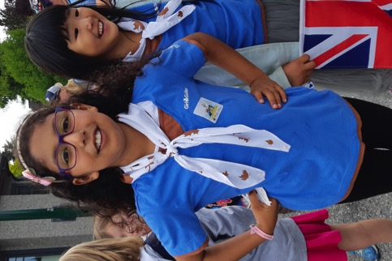
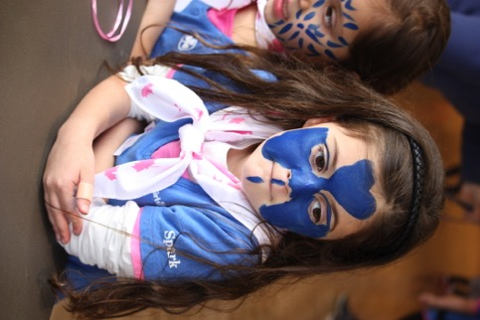

West Coast Area Council
2019 Annual Report

COMMISSIONERS’ MESSAGE

In 2009, three local Areas – Burnaby Royal, Fraser Delta, and Vancouver – amalgamated to form West Coast Area. We are now 10 years old. To commemorate this occasion, each member of the Area was presented with a special crest. We also created an Area jacket and Area vest, which proved very popular for our adult members.

Challenges this past year included phasing in ePact, “Try Now Join Later,” and Guider retention. Guiders also requested detailed strategies for girls who present with challenges, to address Inclusivity and Accessibility in their units. While our new uniform met with mixed reviews initially, most Guiders and girls are now wearing the new t-shirt or tunic.

The waitlists were particularly challenging this year. Thank you to Guiders who opened their units to more girls and to Commissioners who found new venues so we could open new units. Going forward, we realize that the cost and availability of venues will be ongoing issues.

Camping continues to be popular and tops the list every time a survey asks: “What do you like best about being a Girl Guide?” Many Districts hold district camp, which is a great way to get everyone to camp. It also gives new Guiders the experience and confidence to tackle a unit camp on their own. Camp is a terrific bonding experience for both girls and adults. Over the summer of 2019, we saw three successful weeklong camps at Camp Olave – the COMC-sponsored More Seaside Fun, the 35th annual Southridge District Camp, and Holidaze.

In districts, administrative teams are becoming more popular, as a very efficient way to organize and operate. Whether it’s the commissioner position, a finance team, or organizing an event, we recommend these words: Share the load!

The 2019 Area-sponsored trip to India was a huge achievement. This was the first West Coast Area-sponsored trip. Eleven girls and three Guiders visited Sangam World Centre for a week and then spent a second week touring India’s Golden Triangle (Delhi, Jaipur, and Agra). Do you have an idea for a second Area-sponsored trip? Contact your Area Commissioner.

West Coast Area continues an active community presence through our participation in local events – parades (Lunar New Year, New West Santa, Hyack, Point Grey Fiesta, and Vancouver Pride), community days, Remembrance Day ceremonies, Night Quest, shoreline cleanups, and of course selling our cookies.

Service has always been and continues to be an important part of our Guiding life. Across the Area, we’ve found a variety of ways to contribute – care packages of food and hygiene supplies to Nunavut and locally, TELUS Christmas stockings, table favours for Meals on Wheels, Valentines for Vets, donations to the Downtown Eastside Women’s Centre, and Christmas hampers. The New Westminster Guides participated in cleaning military headstones to acknowledge the sacrifices made by our veterans and their colleagues.

Units are taking advantage of community connections, enjoying program from various groups – UBC, Microsoft, Apple, Girls with Grit (mental health workshops), and SPCA, among others.

As you read through the District reports, you will notice a theme – busy, busy, busy! It’s wonderful to see that Guiders are giving our girls such fond memories of their years in Guiding.

Five Orion Rangers were selected as members of the Provincial Youth Forum. They have made their presence known on television interviews and by organizing Provincial conferences and workshops.

Our Area Celebration of Achievement, recognizing the accomplishments of our Pathfinders and Rangers, was held at VanDusen Gardens on June 20th. Forty-six girls were presented with their Canada Cord certificates, and ten Rangers earned the Chief Commissioner’s Gold Award. Nafeesa Karim from CTV was our guest speaker, and she delivered an engaging speech that inspired girls and adults alike.

In January, Burnaby Lakes District said goodbye to Joyce Codron. Joyce was 86 years old and had been a Girl Guide for many years. Joyce and her husband, Hedie, were longtime volunteers at Camp Olave.

The Provincial Commissioner, Leslie Bush, attended the Area Awards Dinner and bestowed the Sovereign’s Award for Volunteers to Rosemary Meech – well-deserved recognition for a dedicated guider.

The Girls’ First program continues to elevate mentoring and bridging between Guiding branches. Our units and districts are increasingly delivering girl-driven meetings, advancements, enrollments, and camps. We are supporting our girls to become more involved in what they want to do and be.

Our term as your Area Co-Commissioners comes to an end in 2020. We have enjoyed working with all of you. Each of us has enlarged her circle of Guiding friends and found a broader sisterhood across our Area. We appreciate all that you do for Guiding, whether you are hands-on with girls in units, work with guiders in districts, or help with Area, Trefoil, or provincial events. 2019 has been a year of change – faced with new information and processes, you manage to flow, adapt, and move forward. We thank you all.

Keep Calm and Ask a Girl Guide!

Hilary Feldman & Elaine Lake
West Coast Area Co-Commissioners

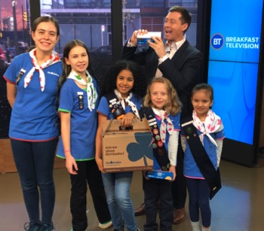
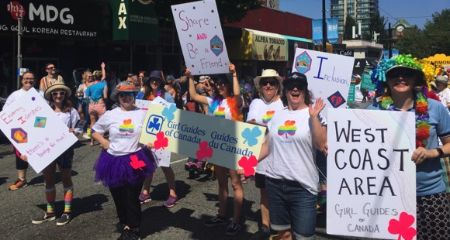
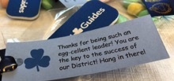
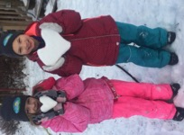
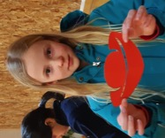
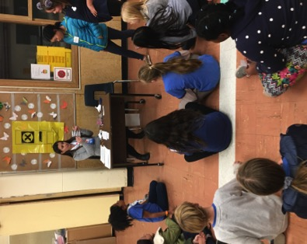
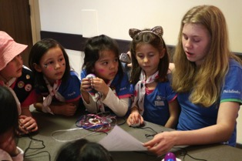
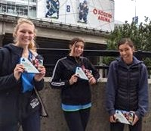
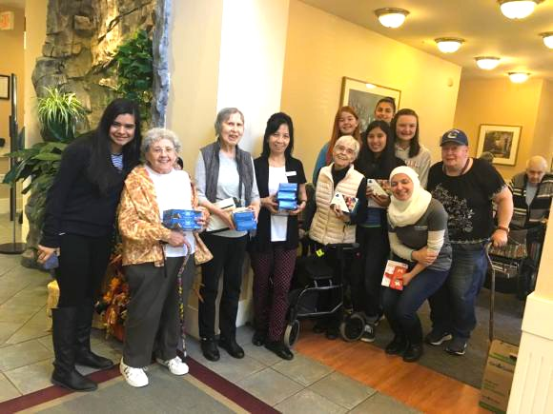
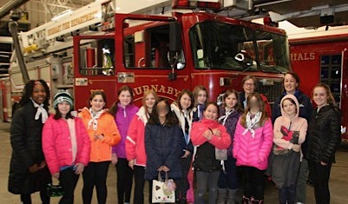
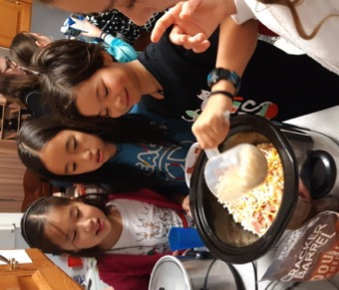
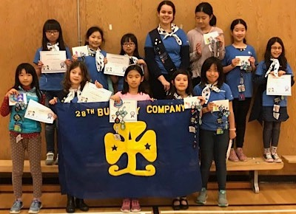
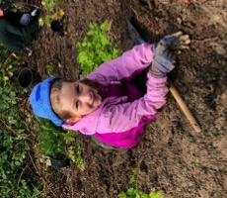
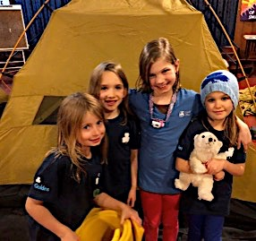
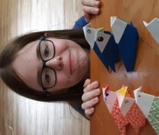
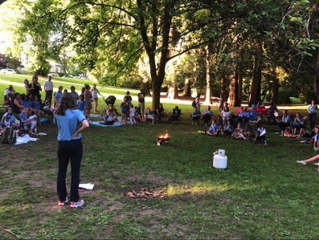
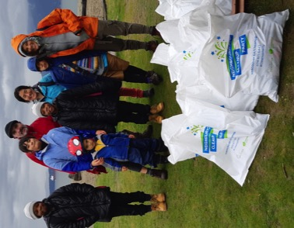
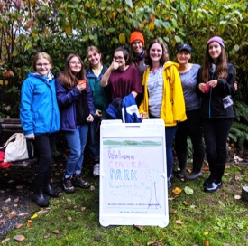
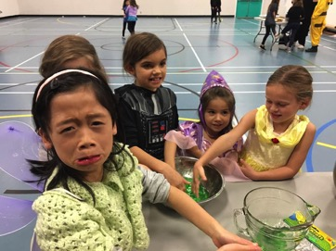
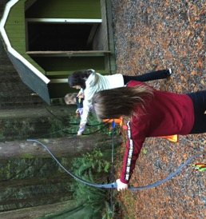
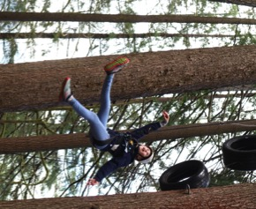
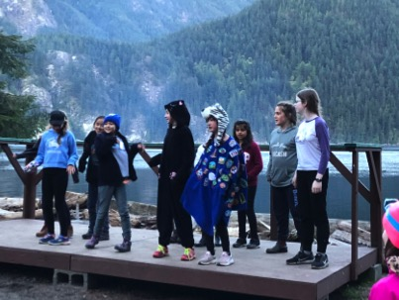
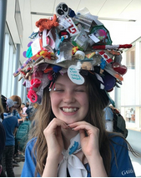
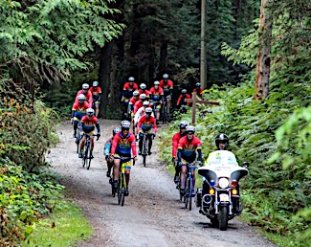
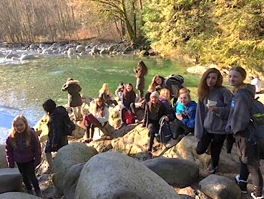
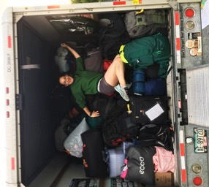
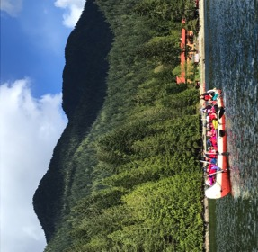
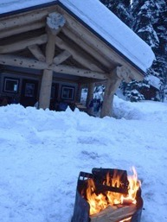
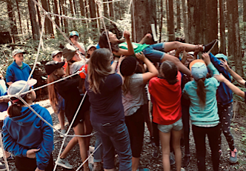
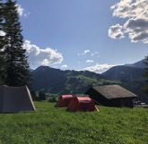
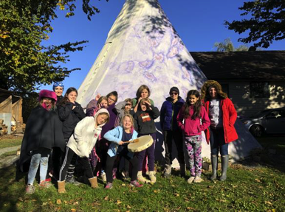
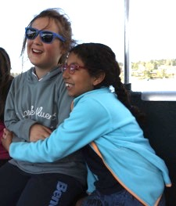
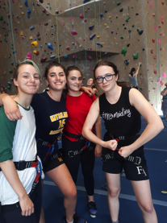
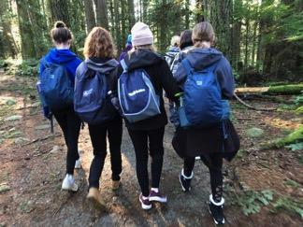
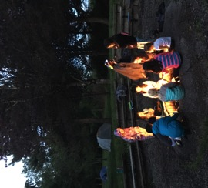
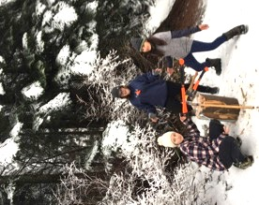
We Camping
WEST COAST AREA COUNCIL

Area Co-Commissioners Elaine Lake and Hilary Feldman
Treasurer Vacant
Secretary Patty Furlan
Awards Chair JoAnn Fox
Camping Adviser Carole Cooledge
COMC Representative Marj McKenzie
International Adviser Adèle Cooshek
Membership Adviser Vacant
Program Adviser Vacant
Public Relations Adviser Vacant
Special Events Chair Joanne Stregger
Training Adviser Jane Read
Webmaster Rosemary Meech
Hollyburn Chalet Shelley Reid, Renata Triveri
Woodwards Landing Gail Rawle
Richmond Guide House Gail Rawle

District Commissioners

Burnaby Glens Stephanie Tripp
Burnaby Lakes Heather Reandy
Burnaby Mountain Gerry Koepke
Burnaby North Rhonda Manson (Jan-May)
Tania Ballantyne (May-Dec)
Kitsilano Fairview Alyssa Koehn & Veronica Singer
Ladner Tsawwassen Muriel Wells (Jan-May)
Nadine Bak (May-Dec)
Mackenzie Heights Barb Munsie (Interim DC Jan- May; DC May-Dec)
New Westminster Sharon Hickin & Fiona Rogan
Ocean Vista Stephanie Bell & Sarah Beairsto
Renfrew Emily Chan
River’s Edge Karen Kielbasa (Jan-Oct)
Sarah Marcinowsky (Oct-Dec)
Southridge Barb McGillivray
West Point Grey Hannah Scott

Thanks for the continuing assistance of these teams:
Finance Denise Dhalian, Judy Emmerson, May Chan, Adrienne Boney, Donna Hillman
Fundraising Approval Donna Hillman, Gerry Koepke, Joanne Stregger

IMIS Support Toki Menendez
Member Support Carla Wilks
MEMBERSHIP 2019

Members: 2,555 Girls and 815 Adults
13 Districts

District | # Girls | # Guiders | Total | Girl:Adult
Burnaby Glens | 115 | 33 | 148 | 3.5
Burnaby Lakes | 121 | 33 | 154 | 3.7
Burnaby Mountain | 148 | 46 | 194 | 3.2
Burnaby North | 149 | 36 | 185 | 4.1
Kitsilano Fairview | 228 | 77 | 305 | 3.0
Ladner Tsawwassen | 196 | 61 | 257 | 3.2
Mackenzie Heights | 273 | 66 | 339 | 4.1
New Westminster | 172 | 56 | 228 | 3.1
Ocean Vista | 144 | 29 | 173 | 5.0
Renfrew | 306 | 85 | 391 | 3.6
River’s Edge | 159 | 44 | 203 | 3.6
Southridge | 313 | 81 | 394 | 3.9
West Point Grey | 222 | 43 | 265 | 5.2
Area Trex & Trefoil | 9 | 125 | 134 | n/a
AWARDS

For the 2019-2020 year, the Area Awards committee approved 56 awards. This is even more than last year, which is wonderful! Normally, these awards would be presented at the Area Awards Dinner in April 2020. However, due to COVID-19, the event was cancelled; these awards will be distributed by Districts either virtually or in whatever way they feel it safe to do so.
Bronze Merit Award 12
Silver Merit Award 4
Special Contribution 3
Team Award 5
Commissioner ACL 2
Gold Thanks Pins 7
The following awards were approved for Districts:
Gold Thanks 8
Bronze Unit Guider 11
Silver Unit Guider 3
Gold Unit Guider 1

CAMPING

In April, the Area Camping Committee organized a Camp Skills Day for girls. Just Gotta Camp was an overnight adventure for Brownies and Sparks at Woodwards Landing in June. An Outdoor Activity Leadership (OAL) Adventure Training was offered in partnership with Fraser Skies Area. The ever-popular Camp Cooking Competition was held at Deas Island in October. OAL Tent Camp Training was offered in October, along with an Introduction to Camp Planning. 2019 finished with a well-attended Snow Series training, in preparation for a series of Winter 2020 snowshoe hikes, a snow camp, and a snowshoeing trek.

INTERNATIONAL

There were two independent trips in 2019 – Charnwood International Camp in England (Ladner Tsawwassen District) and a European adventure that included Our Chalet, Italy, and Greece (River’s Edge District). In addition, girls and adults travelled to India on our first Area trip. We also had numerous girls and adults selected for national and provincial trips to Costa Rica, Kenya, Netherlands, London, and Switzerland. Closer to home, girls discovered Newfoundland and Labrador, Quebec City, and Montreal. Area members participated in DAWN in Newfoundland, LEAP in Ontario, and Taste of Adventure and Amazing Race in BC. It was a well-travelled summer! We thank National and BC Council for offering these opportunities.
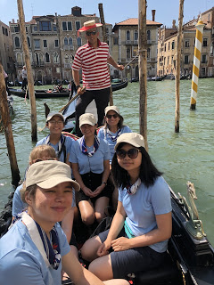

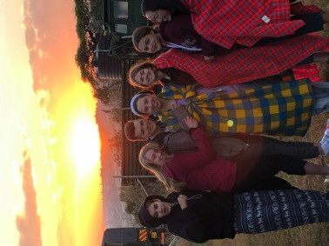

PR

With a vacant Area PR Adviser position, Districts and units managed their own public relations. They kept Guiding in the public eye through participation at community festivals and parades, as well as car-free days. Area participated in the Vancouver Pride Parade in August and hosted a craft booth and cookie sales at the Vancouver Train Expo in November.

PROGRAM

The year began with a Snowflake Ball organized by the Rangers in Burnaby North District. In February, Sparks across the Area celebrated 30 years in Canada with an afternoon of activities designed just for them, including a private concert and dance party with Bobs and Lolo. The SPCA offered Saturday morning programs for Guide units. Our Brownies were invited to UBC for Physics and Astronomy designed for their age. Girls of all ages participated in the Area’s Celebration of International Women’s Day with an amazing Career Fair at the SFU Segal Building on March 9. In May, Guides and Pathfinders Explored Engineering thanks to Geering Up at UBC.

TRAINING

In early 2019, trainings focused on the new Girls First program. In September, the New Guider Training Paths were offered; this series of five courses is designed to ensure that Guiders feel confident and prepared to lead their units. All new Guiders are required to complete these courses within their first six months of joining Girl Guides. The courses are also a great refresher for more experienced Guiders and can be done online or in person. As always, Unit Financial Training was offered to get new treasurers familiar with their role. District Commissioner Training was held monthly from October 2019 (to conclude in March 2020). Safe Guide trainings were held throughout the year, particularly in the fall. A new feature, “Chat with a Trainer,” was introduced this year; these informal sessions can be held at various locations and dates for Guiders to drop by and have a chat about any Guiding subject.

PROPERTIES

WOODWARDS LANDING

Woodwards Landing had a very busy year with camping, day camps, and trainings, as well as many District events. Scouting groups continue to enjoy use of the camp, as well as some City of Richmond-sanctioned events.

RICHMOND GUIDE HOUSE

The Guide House was booked every weekend from September through July, often with a different group each night. We had the pleasure of entertaining out-of-town guests for an extended stay during Spring Break. The summer months are also popular, as the Guide House is a great stop-off from the airport, train, or ferry before each group goes on to their next adventure.

HOLLYBURN CHALET

2019 was a busy year for the Hollyburn Chalet. The weekends are full of energy when girls are camping. Our calendar fills up quickly, and each camp attends an orientation. Each fall, we hold a two-day work party. The chalet is well managed under the watchful eye of Jim and Shelley Reid from Burnaby North District. We received two capital grants this past year. The first grant helped pay for log replacement, as a number of logs had rotted on the front wall of the cabin; the logs had been helicopter-dropped previously, but still had to be cut to size. Additionally, the front porch and stairs needed replacement, receiving the second grant. Our sincere thanks to Bill Johnson and Mike Ratzlaff for completing both projects.

CAMP OLAVE MANAGEMENT COMMITTEE

Our oceanfront paradise continues to be a favourite for so many girls and women. Camp Olave once again had a great year, with more than 4,500 campers making their way through our gates to enjoy a stay at the seashore.

Randy and Sharon Krystalovich, our wonderful Caretakers/On-site Managers, sailed through their second year like old pros, while they kept the camp running and working well through all kinds of challenges.

As done each year, our spring and fall work weekends were held to ready the camp for the summer season in April and then shut down our outdoor sites in October. We sincerely thank all our volunteers for turning up rain or shine and working so hard on those weekends.

Our wonderful lifeguards, a.k.a summer staff, kept busy from sun-up to sun-down, scheduling, lifeguarding, taking girls kayaking, facilitating low ropes, organizing wide games and night games, along with completing a variety of maintenance jobs between camps and much more. They even managed to teach some of the groups a new song or two. Thank you to all the camps that included these young women for meals and donated extra goodies and leftover groceries to them.

At our annual More Seaside Fun camp, girls and Guiders from around the province participated in their usual varied program, which included building rafts, lots of crafts, daily swims, beach exploring, snorkelling, kayaking, archery, low ropes, and many more fun activities. Thank you to all the leaders who help make this camp such a success – and a special thanks to Carell Bell, our Responsible Guider, for continuing this tradition!

Cops for Cancer were very grateful once again to use the camp for a night during their annual ride in September. And, as always, Sechelt Search and Rescue returned in the fall and were so appreciative to be able to run their trainings and mock searches in the perfect setting that the camp provides.

A capital grant from the provincial Properties Committee helped us put a new roof on Galalina Cottage and beautiful new windows in IODE. Other improvements included the second installment of cubbies at Dudes Palace, new washroom sinks at Kwi Kwa, new prep tables and shelving in Galalina cook shelter and pantry, and continued refurbishing of the trails. Repairs to the seawall were completed in November and, hopefully, Mother Nature will be kinder this year.

We continue to be financially self-sustaining, but we are always grateful for donations. We have a wish list prepared by the Site Managers if you would like to help the camp. The Camp Olave Management Committee thanks all Guiders for their support year after year. Please keep in mind that Camp Olave belongs to you and your girls. Come and enjoy the beauty that has been preserved for you and them.

Thank you to Girl Guides of Canada – BC Council for continuing to support Camp Olave with capital grants. The Camp Olave Management Committee wishes to sincerely thank the following Districts, units, and individuals for their generous donations to Camp Olave in 2019: the Estate of Sandra Sharpe, Lions Area, Mackenzie Heights District, New Westminster District, NSEW Trefoil Guild, Jean Reeve, Bridget Monahan, Denise Dhalian, Priscilla Wong, and the Victoria Foundation.

A huge thank you to Matt Stregger, who has been providing us with space for our website for several years now, and to Rosemary Meech, our Webmaster also for many years. Special thanks also go out to Para Space Landscaping and Jeff and Peter Foley for the continued support of Camp Olave with donated labour and materials for our work weekends.

BURNABY GLENS

In February, our Pathfinders created and executed an awesome Thinking Day program for the entire district! It was a big job, and they pulled it off without a hitch. Burnaby Glens District was very well represented at the Area Awards Dinner in April. A few of our Guiders received significant member year certificates, and it was great to see other inspiring Guiders from the Area. On the Canada Day long weekend we hosted 120+ girls for our annual District camp at Camp Olave. All of our 8 units were full in the spring by the end of registration time, with 15 girls on the wait list for one of our units, which was already at 25 girls. Unfortunately, one of our Guide units was closed in September because the main Guider stepped away, and a new team was not found to keep the unit going. We began the new Guiding year by face-painting at the Burnaby Public Library Summer Reading Club Wrap-Up event and at the Rumble on Gray Street Fair. In November, we hosted our annual Holly Tea fundraiser, which provides us with the funds to subsidize the cost of District Camp. We held our annual District skating party in December to wrap up the calendar year, which was a fun time for parents and Guiders and girls to interact with one another. Our DC, Stephanie Tripp, stepped down at the end of December, and former DC, Carla Wilks, stepped in to cover some of the duties in the interim.

BURNABY LAKES

2019 was a busy year for Burnaby Lakes. There were many camps, activities, and of course cookies. We had a huge jump in growth in our District, almost every unit was full, and a brand new Brownie unit opened. We also had several new leaders join us. Sadly, we said goodbye to a long-time Guider, Joyce Codron.

Over the course of the year, we held three District events that were very well attended by each branch and almost every unit! Each event also had a corresponding balloon crest. If a member attended them all, they would end up with a whole bouquet of balloons for their campfire blanket! The best event, according to the girls, was the sleepover at Crash Crawlies.

A few more highlights: three Pathfinders and one Ranger earned their Canada Cord and Gold Chief Commissioner award. Six Guiders received awards for their commitment to Guiding. Continued participation in the New Westminster Remembrance Day Ceremony and Parade. The Pathfinders attended DAWN in Newfoundland. One Pathfinder and one Ranger were selected to attend Provincial and National sponsored events. Continued community outreach and fostering new participation for outreach with face-painting and/or crafts at events, tree planting, and donation/delivery of Christmas hampers.

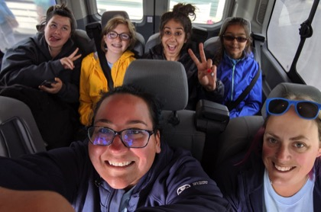
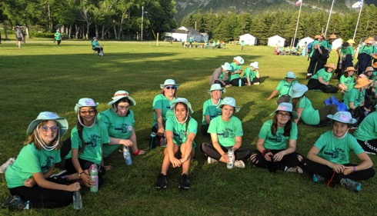

BURNABY MOUNTAIN

2019 was another successful year in Burnaby Mountain District. We will highlight our successes (and comment on challenges) by considering the national strategic priorities for 2018-2020.

Relevance: Grow & Maintain Membership
• Responsive to needs of adult members by providing ongoing training relevant to their needs/interests including Food Safe, Safe Guide, Girls First, GST, and Campfire. We further encouraged participation by running a 2018-2019 training contest – Guiders got an entry for every GGC training they attended, with a draw at our June 2019 district meeting for a gift basket. Our Guiders participated in more training than ever before.
• We continued to run our district website with stories about what our girls and units were up to. This is a good membership tool that has helped us attract new members. Sometimes units were not great at sending in content so there were dry spells on the website.
• We are proud to have awarded three merit awards to well-deserving adult members.
• Our district continued to have a presence at major community events including the Great Salmon Send Off, SFU StreetFest, SFU Volunteer Fair, and Wesburn Family Picnic, and Girls Hockey Tournament.
• Held a membership information night at a local community centre.
• 2019-2020 district focus is membership – started a MINGO (Membership Bingo) game for Pathfinders/Rangers/Adults to promote Guiding in our community. Winner to be announced in June 2020.

Empowering: Exceptional Girl-led Programming & Delivery
• After getting insufficient interest to plan an international trip to Mexico, Burnaby Mountain successfully recruited girls and leaders for a 2021 trip to Ireland. Although it is being organized at the district level, girl participants come from across West Coast Area.
• Thinking Day 2019 was celebrated with a family skating party and celebration. The Thinking Day celebration portion was Pathfinder-led, with the skating party used as a district fundraiser (for Victoria trip). This new format was well-received with 88 participants in the skate party.
• District sleepover for Guides, Pathfinders, and Rangers at Vancouver Aquarium was a big success with 58 participants.
• May 25th day trip to Victoria was listed as one of the girls’ favourite activities of the year –despite HORRIBLE weather that put kinks into just about every aspect of the planning and had most Guiders convinced it was a miserable day. The girls had a fantastic time anyway!
• Lots of bridging events between units including: a great buddy sleepover planned by Pathfinders for Sparks, joint outings to places like 4Cats, snowshoeing, camps, etc.
• Units have embraced Girls First delivery, finding innovative age-appropriate ways to get girls to lead programming choices.
• Pathfinders and Rangers were invited to the planning portion of the August district planning day to provide insight and direction for our district events.

Diversity & Inclusion: Representing Today’s Girls and Women
• Inclusivity reminders given at district meetings to ensure all members treated fairly.
• Providing childminding during district meetings allowed more adult members to come out to meetings. A Pathfinder going on an international trip provided the childcare and received an honorarium towards her trip.
• We encouraged First Nations Acknowledgement be made at large events.

Agile: Being Operationally Excellent & Nimble
• Despite a lot of planning work done by the committee, the proposed District Family Camp event did not get enough interest. The event was cancelled to preserve resources for better received programming.
• To better serve our community, the district decided to blend the 2nd Sparks and 47th Brownies so that we could continue to offer units on Saturdays. There were not enough girls or leaders to sustain two separate units, but together they work and the families really appreciate having a Saturday option.
• District developed updated suggestions/guidelines for good adult communication, e.g., e-mail and texting etiquette.
• Facilitated a district swim test day to help units get girls and Guiders properly recorded in iMIS with their completed swim tests. This took some administrative load off units.
• Updated deposit procedures to better track unit-level finances.
• Established DC liaisons for all units and district events to better distribute workload between the DC and her deputies and to keep lines of communication open.
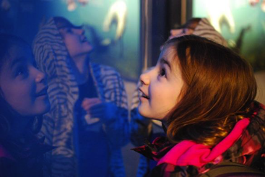
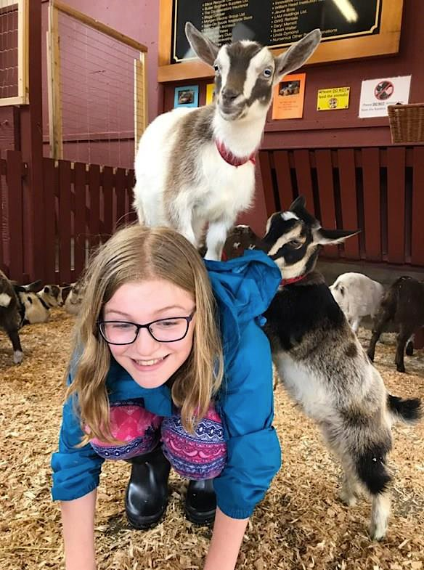
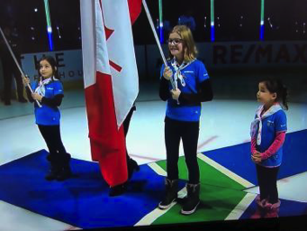
Colour guard at BC Girl Guides Vancouver Aquarium
at the Canucks day

Beacon Hill Park petting zoo
on District Victoria trip
BURNABY NORTH

This year has been an interesting one, to say the least, for all Girl Guides. We began the year with a shortage of adult volunteers and, unfortunately, had to close one of the Brownie units in our District. With the help of the District Commissioner, we managed to keep two other units open until we found enough leaders to make the units sustainable.

We currently have 1 Spark unit, 2 Brownie units, 3 Guide units, 2 Pathfinder units, and 1 Ranger unit operating in our District. There are Rangers and Pathfinders using their leadership skills to help mentor younger members in the role of Junior Leaders for Brownie and Guide units.

We are fortunate to have Guiders in our District who do not let things like rain and snow keep them from taking members to camp during the winter months.

Our Sparks and a Brownie unit spent an afternoon hiking in the snow up at Hollyburn while our Pathfinders and Rangers spent time camping at Hollyburn. A Guide unit camped at Camp McLanlin over the Family Day weekend and another Guide unit spent the night at Richmond Guide House before touring the local cannery.

One of our Pathfinder units participated in an epic Manning Park snow camp in February with snow tenting, outdoor cooking, snowshoeing on the lake, snow sculpting and cave-digging, and boots that froze solid on the second night.

We had units participate in the Area Cooking Challenge and our District held a Thinking Day event organized by a few of our Pathfinders.

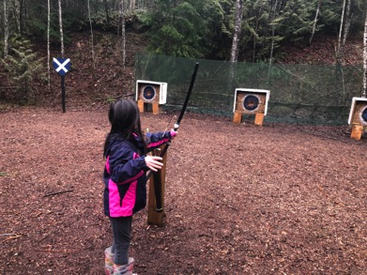
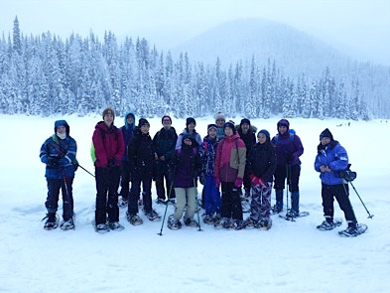

KITSILANO FAIRVIEW

2019 was a fun and busy year for Kits Fairview District! In January, our Pathfinders took a self-planned trip to Victoria for the weekend, staying in a hostel and exploring the city via transit. It was a wonderful trip and a great lesson in planning and organization. We also held our annual Guider retreat to Camp Olave – we had a great time and surprisingly wonderful weather for winter! New Guiders enjoyed getting to know the site, and we all enjoyed spending some cozy and quality time together.

In February, we celebrated Thinking Day with our annual district event. We learned about some WAGGGS World Centres, played games, and made crafts to further explore the theme of Leadership. Our Pathfinders helped facilitate the activities and made great leaps in leadership themselves.

Throughout the spring, our units held sleepovers at Richmond Guide House, the Space Centre, Midnight Cheer, A&T Equestrian, and more. We also hosted our second district Brownie camp at Camp Kanaka. The Brownies explored outside during the springtime and had a wonderful opportunity to build their confidence sleeping away from home. The Sparks held their first sleepover of the year at Midnight Cheer, helped by their wonderful Pathfinder assistant. One Guide unit held a Mother’s Day mom/daughter sleepover at Camp Kanaka as well! We held our annual district camp at Camp Olave, where we took over the camp! We had a great turnout and wonderful weather. Our members enjoyed archery, swimming, crafts, games, scavenger hunts, and amazing food! Our theme was Space, and we had some amazing Pathfinder-planned games and crafts to round out our programming.

Of course, April and May in our district mean: Cookie Sales! Skytrain stations were booked every week, and our members were out selling cases rain or shine!

In June, some Guide units held camp skills and tenting camps at Woodwards Landing, to help the girls learn more about their abilities in the outdoors. Brownie and Guide units also completed Shoreline Cleanups around the district, and certainly cleaned up some very interesting items including bicycle tires and even a large whiteboard! At our advancement, one of our Pathfinders earned her Canada Cord, and 5 Guides earned their Lady Baden-Powell awards. Over the summer some of our Guiders and girls joined the WCA group in the Vancouver Pride Parade.

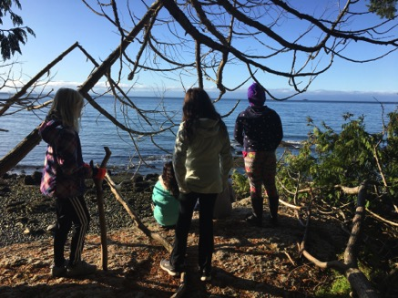
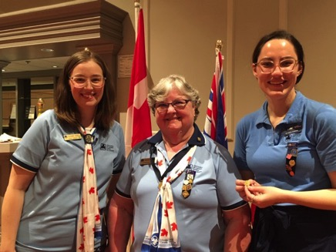

LADNER TSAWWASSEN

Our District has 3 Spark units, 5 Brownie units, 4 Guide units, 2 Pathfinder units, and 1 Ranger unit. We also have a Guiding unit with 10 girls ranging in age from Sparks to Rangers. Last summer, we sent an independent trip to Charnwood International Camp in the UK, after a lot of fundraising effort and community support.

MACKENZIE HEIGHTS

This year, Mackenzie Heights District built on our past successes and continued to embody our core values: Resilience, Relationships, Leadership.
Our District Council took an in-depth look at adult membership, what it means, how we define it, how we measure it, and how we can be sure our adult members experience Guiding in the best and most rewarding way. While girls are the focus of everything we do, nothing happens without our adult members, and we want to be sure we invest in their wellbeing as well as that of the girls. We now have a consensus as to what our district‘s adult membership priorities are, and a new catchphrase: “Every Guider An Active Guider.” Each of our Guiders knows she is needed, has the opportunity to be fully engaged, and is able to reap all the benefits of being a leader to today’s girls in Guiding.
An immediate benefit from this was that two current Guiders stepped forward to revive one of our Pathfinder units that had not opened in 2018-19 due to lack of leaders. This has enabled us to accommodate 32 girls in Pathfinders for 2019-20. The fall of 2019 saw the creation of two Spark/Brownie unit teams sharing meeting spaces and times to make better use of our Guiders’ availability and resources, while ensuring that we could open all our units. The Guiders involved have made a complete success of this venture, and parents have given positive feedback.
Mackenzie Heights girls continue to blossom with creativity and leadership, embracing the Girls First program. Some of our unit activities – all of them girl-requested and many of them girl-led – have included:
Sparks:
- Crafts! And more crafts
- A month of meetings focusing on kindness and helping in our community, culminating in 4 boxes of food collected and $130 raised for the Vancouver Food Bank
Brownies:
- Sent 2 teams to participate in the Science Games put on by the Engineers and Geoscientists BC, and one of the teams won first place in their division. The other team was featured in a newspaper article about the event.
- Video-recorded a skit written and acted by the girls, and had a screening for the parents
- Hosted meeting visits from UBC Physics and Astronomy Outreach to learn about circuit boards and make very cool LED flashlights
- Hosted a meeting visit by an artist, who led the girls in creating a dandelion painting.
- Rode the SeaBus as part of a transportation-themed series of meetings
- Sleepovers at the HR MacMillan Space Centre, Richmond Guide House, Southlands Farm
- Camps at Camp Olave, Camp Kanaka, Camp McLanlin
- Hosted a meeting visit from a lady from Musqueam Band who taught the girls how to make cedar bracelets
- Held a joint Valentine’s Day meeting with their sister-Spark unit. This meeting was completely planned by the girls.
- Completed the Quebec Chocolate Challenge
- Attended a taping of the Gumboot Kids TV show, complete with a behind-the-scenes tour
- Completed the Women of Valour Challenge
- Halloween parties planned by the girls
Guides:
- Weekend Camps! At Camp Olave, Camp Capilano, Woodwards Landing, Camp Kanaka, Camp McLanlin, Fort Langley
- Sleepovers at Richmond Guide House, Southlands Farm
- Completed the Great Canadian Shoreline Cleanup as a unit activity
- Engineering Challenge (multiple units), including making water slides using recycled products from home, plastic wrap, and tin foil. Some 3rd year Guides completely planned and presented an engineering instant meeting.
- Girls Count Challenge completed by multiple units
- Completed the Quebec Chocolate Challenge
- Indoor climbing, ice skating, swimming
- Sushi Night, which included sushi candles as well as candy sushi
- Halloween parties planned by the girls
- Enrollment night ceremony and celebration planned entirely by the girls
Pathfinders:
- Sleepover at Lighthouse Park, sharing the booking with a group from Gabriola Island who they had never met before
- Make Your Own Spa night
- More Than Money Junior Achievement program
- Girl-led evening learning about coding
Rangers: 2 girls were selected to travel to Kenya in the summer

Our girls and Guiders have also taken advantage of opportunities and support provided by our District, Area, and Provincial councils, including: Rainbows and Toadstools provincial training for Spark & Brownie Guiders, Girls Can Do It career fair, District Snowflake Ball, Hands Across the Border, Camp Cooking Challenge, Rally on the Shores, and Just Gotta Camp.

NEW WESTMINSTER

New Westminster has had another successful year! We now have 3 units at each of the Spark, Brownie, and Guide levels, a full Pathfinder unit, and 10 Rangers. We also added 10 new adult volunteers to our roster – yay! We are excited to have Guiders with a wide range of experience. More than ten of our leaders were presented with 25+ years of service awards this year. All our volunteers are finding new and creative ways to share their knowledge and experiences of the program with our Guiders and learning how to adapt their current programming to fit the new modules. Their success is evidenced by 4 Lady Baden-Powell, 6 Canada Cord, and 4 Gold Chief Commissioner’s Awards presented to girls this year. Well done, girls – we are so proud of you all! Guiders attended trainings in Basic and Wilderness First Aid, OAL, QM, camp skills, Safe Guide, Inclusivity and Diversity, and Girls First.

We celebrated and were visible to our community in very many ways throughout the year, from participating in the local Santa and Hyack Parades, hosting booths at Volunteer Fairs, and offering our services at the community weed and invasive species pull at Glenbrook Ravine. Sparks and Guides took part in cleaning headstones to acknowledge the sacrifice of our veterans and joined in Remembrance Day services and holiday celebrations at local seniors residences. Older girls and adult members provided gift-wrapping services by donation at our local mall, raising over $2,000 in two weeks. Great job, wrappers! As part of their Urban Camp, Pathfinders collected donations and delivered them to Covenant House who were most grateful for the items.

Our units offered many opportunities for learning, personal growth and development, and outdoor experiences. Every unit attended at least two camps and/or sleepovers, and many went to multiple camps as bridging events with their peers from other units or branches. Sleepovers were held at the Space Centre, church halls, and the new provincial Guide House in North Vancouver. We had 6 patrols attend Canada Cord Camp, and the Pathfinders held a cycle trip around Vancouver Island, staying at youth hostels and GGC properties. Rangers attended Camp Skeeter and had lots of fun! More than 8 units visited Camp Olave, Sparks went to Camp MacLanlin, and Pathfinders camped at Deas Island and Woodwards Landing.

Girls participated in Area and Provincial events including the Snow Series, Rally on the Shores, Camp Cooking Challenge, and International Women’s Day career fair. Units held meetings with guests from all walks of life, visited an animal shelter and the library, went bowling, and made Mother’s Day gifts with residents of a care home.

District events included our annual Skate at which donations were gathered for Christmas hampers for families in our community. We managed to fill 6 hampers to overflowing and had surplus to share with others. Well done, girls! Our Advancement ceremony was held in beautiful Friendship Gardens, with a traditional campfire and singalong with hot dogs and s’mores after the official presentation of awards and pins. We held a fun District Camp at Camp Capilano in December. In order to accommodate all the girls, Brownies and Guides spent Friday night at camp, while Pathfinders and Rangers slept over on Saturday night. All girls (including Sparks) attended our activity day at Grouse Mountain on Saturday. Activities included visiting the Hiwus Feasthouse, where the girls learnt and participated in a traditional story dance; ice skating; visiting the bears and wolves; and enjoying the gondola ride up and down the mountain. The best part was the snowball fight at the end of the day. Great fun was had by all!

New Westminster girls were well represented as travellers this year. Five girls were selected for provincially or nationally sponsored trips to BC, Europe, Kenya, and Costa Rica. New Westminster may not be the largest District in West Coast Area, but we think it sure has the best leaders! To acknowledge the hours and effort that our valuable adult members give to our girls, Fiona and Sharon were pleased to host the annual Guider Getaway. Our Guiders enjoyed time together, sharing plenty of laughs, and were presented with their Thank You gifts. It has been our privilege to work with this wonderful group of dedicated women again this year and although our term as Commissioners ends in June 2020, we know that we are leaving the district in good shape and that they will support Christina Armstrong as she takes up the reins.

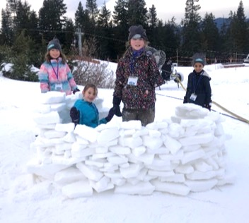
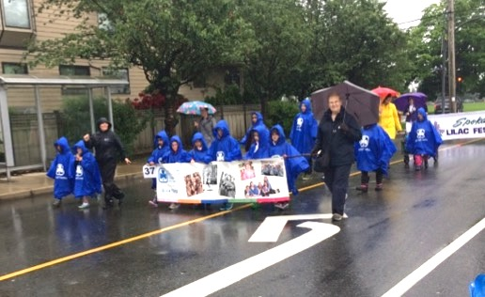

OCEAN VISTA

The past year has been one of great changes, both in terms of learning about and experimenting with the new program, as well as changes in the district leadership team. Through the changes, we have come to focus on and solidified what we value as members of Girl Guides of Canada – Ocean Vista District. We are excited to move forward, welcome new members, and continue to grow Guiding in Richmond. Here are a few highlights of the activities in Ocean Vista District over the past year:

- Our district came together in October for a highly successful 3-day district camp at Camp Olave in Sechelt. The participants enjoyed all the typical camp activities such as archery, crafts, campfire, and wide games as well as the unique friendship and bridging opportunities only available at a multi-level camp such as our annual district camp.
- In December, we came together for a district family skating night at Minoru Arena.
- In February, our Rangers organized a well-executed and eventful World Centres tour event for Thinking Day.
- Working as a district team to facilitate simultaneous district cookie blitzes continues to be a very successful strategy for cookie-selling in Richmond.
- Units are also working together, for example the 1st Richmond Brownies invited all the other Brownies in our district to their Mother/Daughter event.
- This year, we welcomed a new District Commissioner team, but then lost one of the members after a few months when she moved away. Nonetheless, the remaining two co- Commissioners are committed and enjoying their new roles.
- We continue to struggle with units that are at or above capacity and not enough adult leaders. This is taxing to the leaders in the units and makes retention challenging. Luckily, we are blessed with very dedicated group of Guiders, but we continue to look for effective adult recruitment strategies.
- As our ongoing need for more adult Guiders continues, we looked to creative ways to attract new Guiders to be able to welcome as many girls as possible into our district. We had a mixed Spark/Brownie unit that provided an opportunity to mentor new leaders and our joint Pathfinder/Ranger unit ensured there were enough older girls to make conversations and activities meaningful.
- All units have dived into the new Girls First program. We are lucky to have a Girls First champion in our district who has helped as needed and shared her expertise at district meetings and events.

RENFREW

2019 was another year of growth and adventure in Renfrew District. We had great success with quality ongoing programming, as well as special events throughout the year.

- We continued to have overwhelming interest in our units, and worked to place girls by recruiting new Guiders throughout the year. The 50th Vancouver Pathfinders opened in September 2018, and we planned for the 10th Vancouver Sparks to begin September 2019, bringing us to 18 units.
- In April, we had our first District Camp in recent memory. Very well attended, we had 186 members from Sparks to Guiders who enjoyed classic camp fun with an “Under the Sea” theme at beautiful Camp Olave. We also began plans for branch-specific camps for 2019-2020, starting with a Pathfinder leadership retreat and a Spark-and-mom camp in the fall.
- We marked the end of the Guiding year with an “Up We Grow” themed district-wide advancement ceremony planned and executed by youth and Guiders. Youth from each unit shared ways Guiding helped them grow in front of a huge crowd of members and families.
- Guiders continued to network and create community as we met socially in June and December, for the West Coast Area Awards Dinner, and for a training retreat in September.
- Units enjoyed participating in large Guiding events, including the Sparks 30th Birthday Party, Rally on the Shores, Pedals, Paddles, and Packs inter-area Pathfinder camp, and the Girls Can Do It career fair. Many youth and Guiders in our district also attended Holidaze camp in the summer.
We had amazing representation in the selections for Nationally Sponsored Trips, with one Pathfinder travelling to London, another Pathfinder attending DAWN in Newfoundland, and a Guider selected to attend the Juliette Low Seminar in Oman. Other Guiders in our District also attended DAWN as core staff.

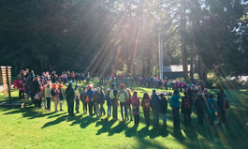
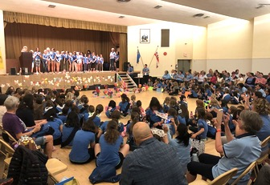

RIVER’S EDGE

River’s Edge members enjoyed another delightful year full of adventures. This year’s District events included a District Thinking Day Celebration, District Camp at Camp Olave featuring a Mexican-themed potluck, and our continued participation in Richmond’s Songs in the Snow and the Gulf of Georgia Cannery’s Festival of Trees (2nd place). We were pleased to continue the tradition of carolling around Steveston Village dressed in period costumes to bring more holiday cheer to the community.

Units were active this year with a variety of different activities ranging from STEM to learning all about Canada. The Pathfinders worked on their Citizenship Certificates while also learning all about the election process during the fall federal election. Many units participated in a variety of service projects from creating Christmas cards to making birthday boxes to send to northern communities to ensure that everyone can celebrate their birthday! Guest speakers this year featured presenters from Science World to learn about marine life and octopus, as well as an electrical engineer to learn all about electricity. Units also engaged in a variety of bridging events to bring girls of multiple ages together to learn and experience new adventures. Some of the out-trips this year were snowshoeing, skating, a tour of the Gulf of Georgia Cannery, Kidtropolis, and Clip and Climb.

True to Guiding traditions, our units enjoyed a variety of camping experiences at Camp Olave, Phyl Munday Nature House, Southlands Heritage Farm, and many sleepovers at Richmond Guide House. In addition, Rangers participated in an independent trip to Europe in August 2019, which was a multi-destination trip that included a trip to Our Chalet in Switzerland. All in all, it was an amazing year of Guiding adventures for the members of River’s Edge.

SOUTHRIDGE

- We had 382 girls by December, a 2.3% increase. We’ll take any increase we can get!
- The year was full of sleepovers, weekend camps, snow camps, and, of course, the District Camp at Camp Olave. One Pathfinder unit travelled to Alberta, staying in both Calgary and Edmonton.
- Units used many ideas with the new programme, and we saw lots of bridging activities that were much appreciated by the Sparks and Brownies.
- We were able to donate $1,120 to Camp Olave and asked to earmark it for the new singing gazebo (fondly called “Muriel’s Singing Place”).
- District Camp in August was themed “World Festivals” – complete with a parade, a fun carnival day, and the usual swims and barbecue night. It was lovely to see all the units together for campfire.
- It was another good turnout for our October Great Canadian Shoreline Cleanup. The weather was good, and the girls collected a terrible number of cigarette butts as well as other litter over the morning.
- Guiders disappeared up to Camp Olave for a retreat – cunningly planned around a weekend of craft sales and bazaars. They reported fun times at lunch outings and enjoyed potluck dinners.
- Our District event involved three busloads of girls and Guiders heading to Britannia Mines for programmes and lunch. Girls voted panning for gold as their favourite activity.
- At one of our District meetings, we benefitted from a session on “Keeping Track of Cookies.” We were shown Air-Tol as a possible app.
- We continue to need new Guiders and meeting spaces to keep up with the challenge of girls on wait lists.
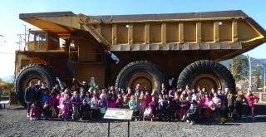
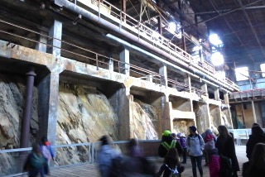

WEST POINT GREY

Our girls and guiders love to get outside – especially at camp; units started the year with winter camps and sleepovers at Camp Olave, Camp Capilano, Fort Langley, Shadow Lake, and Richmond Guide House. As the weather warmed, we had an amazing district camp at Camp Jubilee, followed by unit sleepovers and camps at Camp Kanaka, Cultus Lake, Phyl Munday Nature House, Aldergrove Zoo, and more. Themes ranged from an “Amazing Race” to horses, sloths, and board games. Bridging events were very successful, including multiple Brownie units, Guides/Pathfinders, and Pathfinders/Rangers.

We participated in many Area events, from 30 Years of Sparks and Career Day to Explore Engineering, Just Gotta Camp, and the Camp Cooking Contest. Guides attended the provincial Mix It Up camp in Mission, while Pathfinders and Rangers explored new interests at the Ignite conference in Richmond.

Our district participated in local community events that shape each year. We operated the concession at Night Quest in Pacific Spirit Park, organized an annual shoreline cleanup, ran a craft booth at the UBC Apple Festival, laid a wreath in the UBC Remembrance Day ceremony, helped at Nite Hike, and walked in the Point Grey Fiesta Day parade. This year, we also had a craft station at the UNA Neighbours Day – where some teacher-guiders saw a lot of surprised students!

Particular successes this year: We had wonderful retention of girls from branch to branch. Girls and guiders were selected for GGC trips to Costa Rica, Kenya, and Newfoundland, while others travelled to India on the Area trip. We combined a one-night Guider Getaway with a Spark and Ally mini-camp the next night – this approach was a great way to get guiders, girls, and parents/allies to camp while spreading the cost. Five of our Rangers were on the provincial Youth Forum. Our guiders were very engaged, including being on Area committees like the camping and international committees, provincial camping and international committees, as well as the provincial Safe Guide Adviser and more. Our large district advancement ceremony was entirely girl-led this year; the Ranger co-MCs did an incredible job.

We continued to face ongoing challenges, including: increased girl registration (therefore large wait lists); reduced guider numbers (e.g., a group of guiders moving to another district); and meeting place insecurity (e.g., a closing church). Teamwork will help us overcome these challenges!

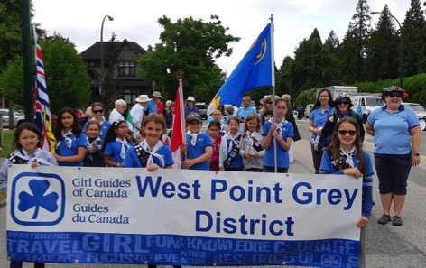
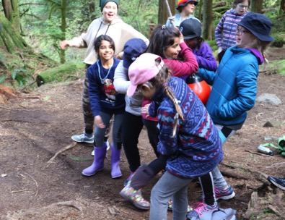

RESOLUTION OF THANKS

Thank you to the following contributors for supporting the development of Guiding in West Coast Area. You are making a difference for girls and women.

Guiders, Commissioners, Trefoil Guilds, Advisers, and Committee Members – for giving your time and knowledge to care for our girls and women.

School Boards, Parks and Recreation Boards, Community Organizations, and Places of Worship – for providing use of your facilities for meetings and event spaces.

Local Businesses, Organizations, and Transit Agencies – for lending support and providing public opportunities to sell cookies that power our programs.

Parents and Guardians of girl members – for enrolling your daughters in Guiding and contributing to the organization of events, activities, camps, cookie sales, and more.

Families and friends of our adult volunteers – for supporting our Guiders as they work to empower girls and women in West Coast Area.

